**Project #3. Personal Narrative Essay**

Think of an experience in your life that supports the theme “If you never have a dream, you’ll never have a dream come true”. Write a personal narrative essay that supports this theme.

In your essay, you need to:

* Have a **clear thesis statement.**
* Share **an incident** from your life to support the thesis statement. The incident should have a **conflict or a tension**; should share **your emotional change**; should be **limited in** time (not a long story); should **support your statement**.
* After your writing, you need to highlight the following parts in your writing:
  + Thesis statement
  + Conflict and tension
  + Emotional change
* See example of highlighting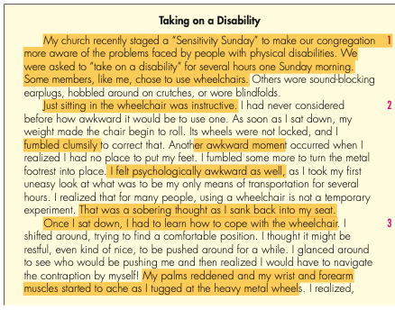
* Submit by Sunday night 11:59pm.
* Read the rubric carefully and include the rubric in your article.

|  |  |  |
| --- | --- | --- |
| **Rubric: Writing project #2 Informational Essay** | | |
| **Point** | **Rationale 评分理由** | **Suggestions 建议** |
| 10 | * The writing has a very clear thesis statement, and it is supportive of the theme “If you never have a dream, you’ll never have a dream come true.” * There is a clear and detailed narrative of an incident and the incident has clear a conflict/tension. * The author describes their emotional change in the incident with good details * This incident fully supports the thesis * The writing is the author’s **genuine work**. It is not plagiarized work from others. * The writing has **minimal grammar/spelling** mistakes. * The essay follows the format and organization:   1. Paragraphs and topic sentences   2. List the author’s name at the top of the essay.   3. List the word count at the end (at least 250 words)   4. Include the rubric in the paper. | No suggestions. Continue with your good work. |
| 7-9 | * The writing has a somewhat clear thesis statement, and it is supportive of the theme “If you never have a dream, you’ll never have a dream come true.” * There is a **somewhat** clear and detailed narrative of an incident and the incident has a somewhat clear conflict/tension. * The author describes their emotional change in the incident with a few details * This incident somewhat supports the thesis * The writing is the author’s **genuine work**. There may be some words and phrases from elsewhere, but mostly is the author’s own work. * The writing has **some** mistakes. * The essay follows the format and organization, and/or misses one:   1. Paragraphs and topic sentences   2. List the author’s name at the top of the essay.   3. List the word count at the end (at least 250 words)   4. Include the rubric in the paper. | Read your essay again and consider how to add more details, correct grammar mistakes. |
| 5-6 | * The writing has an unclear thesis statement, and it is supportive of the theme “If you never have a dream, you’ll never have a dream come true.” * There is an **unclear** and less detailed narrative of an incident and the incident does not have details or conflict. Or the incident is missing in this paper. And/or * The author does not describe their emotional change in the incident, or with little details. * This incident fails to support the thesis * The writing is partially the author’s **genuine work and some parts are from other places without proper citations**. * The writing has **a number of** mistakes. * The essay misses two more of the following formatting components   1. Paragraphs and topic sentences   2. List the author’s name at the top of the essay.   3. List the word count at the end (at least 250 words)   4. Include the rubric in the paper. | Read your essay again and consider how to add more details, correct grammar mistakes. Remember to follow the instructions. |
| 2-4 | * The writing does not have any thesis statement * There is an unclearand less detailed narrative of an incident and the incident does not have details or conflict. Or the incident is missing in this paper. And/or * The author does not describe their emotional change in the incident, or with little details. * This incident fails to support the thesis * The writing is partially the author’s **genuine work and some parts are from other places without proper citations**. * The writing has **many grammatical/spelling** mistakes. * The essay misses three more of the following formatting components   1. Paragraphs and topic sentences   2. List the author’s name at the top of the essay.   3. List the word count at the end (at least 250 words)   4. Include the rubric in the paper. | Rewrite your essay.  Do not plagiarize work again. |
| 1-0 | * The author did minimal work, *or* * The work was totally plagiarized or the work was from online translation (the work does not reflect the author’s proficiency or voice) * Did not follow the format requirements. | Rewrite your essay. |

Your name: __________

Write your paper here: